**RV COLLEGE OF ENGINEERING®, BENGALURU-59**

**(Autonomous Institution Affiliated to VTU, Belagavi)**

**DEPARTMENT OF COMPUTER SCIENCE AND ENGINEERING**



**AI POWERED MEDICAL LABORATORY**

**WEB FRAMEWORKS**

**VI SEMESTER**

**OPEN-ENEDED PROJECT REPORT**

**Submitted by**

|  |  |
| --- | --- |
| **Kiran H R** | **1RV23CS405** |
| **Manoj Kumar B V** | **1RV23CS407** |
| **Nagaprasad Naik** | **1RV23CS410** |
| **Wilson** | **1RV23CS421** |

**Under the guidance of**

Prof. Manonmani S

Assistant Professor

**Bachelor of Engineering**

**in**

**Computer Science and Engineering**

**2024-2025**

**Abstract**

The AI-Powered Medical Laboratory is an innovative project that leverages Artificial Intelligence (AI) and Machine Learning (ML) to enhance the accuracy, efficiency, and reliability of diagnostic laboratory services. The system is structured into three primary modules: the Customer (or Patient) Interface, the Doctor's Portal, and the Lab Assistant Module, each playing a crucial role in the end-to-end diagnostic workflow. By automating critical processes such as test recommendations, result interpretation, and anomaly detection, the system aims to significantly reduce human errors, minimize operational costs, and accelerate turnaround times for test results. This integration of AI/ML into laboratory medicine holds the potential to transform healthcare delivery by enabling data-driven decision-making and improving overall patient outcomes and satisfaction.

Despite its advantages, the project faces notable challenges, including ensuring the quality, availability, and security of medical data, the requirement for substantial computational resources, and addressing concerns related to trust, transparency, and acceptance among medical professionals and patients. Additionally, proper education and training are essential to ensure smooth adoption and effective usage of AI tools in clinical environments.

The project employs a variety of open-source AI/ML tools and frameworks such as Python, R, TensorFlow, PyTorch, scikit-learn, pandas, NumPy, matplotlib, and seaborn for data preprocessing, model training, evaluation, and visualization. Through intelligent automation and advanced analytics, the AI-Powered Medical Laboratory aspires to be a step forward toward smarter, faster, and more accessible diagnostic services.

**Table of Contents**

**Page No**

**Abstract** iv

**List of Tables** vii

**List of Figures** viii

|  |  |  |
| --- | --- | --- |
| **Chapter 1**  **Introduction** | **1-3** | |
| 1.1. State of Art Developments | 1 | |
| 1.2. Motivation | 2 | |
| 1.3. Problem Statement | 2 | |
| 1.4. Objectives | 2 | |
| 1.5. Scope | 3 | |
| 1.6. Methodology | 3 | |
| **Chapter 2** | |  | |
| **Overview of AI and ML Component in the Problem Domain** | | **4-5** | |
| 2.1. Introduction | | 4 | |
| 2.2. Relevant Technical and Mathematical Details | | 4 | |
| 2.3 Summary | | 5 | |

|  |  |
| --- | --- |
| **Chapter 3**  **Software Requirements Specification of AI Powered Crop Price Recommendation System** | **6-7** |
| 3.1 Software Requirements | 6 |
| 3.2 Hardware Requirements | 7 |

**Chapter 4**

**Design of AI Powered Crop Price Recommendation System 8-10**

|  |  |  |  |
| --- | --- | --- | --- |
| 4.1 System Architecture | | 8 | |
| 4.2 Functional Description of the Modules | | 9 | |
| 4.2.1. Data Collection and Preprocessing Module | | 9 | |
| 4.2.2. AI/ML Model Processing Module | | 10 | |
| 4.2.3. User Interface and API Integration Module | | 10 | |
| **Chapter 5**  **Implementation of AI Powered Crop Price Recommendation System** | **11-12** | | |
| 5.1. Programming Language Selection | 11 | | |
| 5.2. Platform Selection | 12 | | |
|  |  | | |
| **Chapter 6** | | |  |
| **Experimental Results and Analysis of AI Powered Crop Price Recommendation System** | | | **13-18** |
| 6.1. Evaluation Metrics | | | 13 |
| 6.2. Experimental Dataset | | | 14 |
| 6.2.1. Dataset Structure | | | 14 |
| 6.2.2. Preprocessing Steps | | | 14 |
| 6.2.3. Visualisation of dataset | | | 15 |
| 6.3. Performance Analysis | | | 17 |

|  |  |
| --- | --- |
| **Chapter 7** |  |
| **Conclusion and Future Enhancement** | **19-20** |
| 7.1. Summary | 19 |
| 7.2. Future Enhancements | 19 |
|  |  |
| **References** | **21** |
| **Appendices** | 22 |
| **Appendix 1: Screenshots** | 22 |
|  |  |

**List of Tables**

|  |  |  |
| --- | --- | --- |
| **TABLE NO.** | **TITLE** | **PAGE NO.** |
| 1 | Performance Comparison | 18 |

**List of Figures**

|  |  |  |
| --- | --- | --- |
| **FIGURE NO.** | **TITLE** | **PAGE NO.** |
| 1 | System architecture | 10 |
| 2 | Dataset header | 15 |
| 3 | Correlation between numerical attributes | 15 |
| 4 | Data distribution of Target attribute | 16 |
| 5 | Scatter plot for Outlier detection | 16 |
| 6 | Target variable analysis | 16 |
| 7 | Pair plot for relationship between attributes | 17 |
| 8 | Comparison between Models | 19 |
| 9 | Price Trends for Commodity | 22 |
| 10 | Price Prediction | 22 |
| 11 | User Interface | 23 |
| 12 | Analytics | 23 |

**Chapter 1**

**INTRODUCTION**

The AI-based Medical Laboratory (AI-MedLab) project seeks to revolutionize diagnostic healthcare by developing a smart, AI-integrated medical laboratory system designed for use by diverse stakeholders, including patients, physicians, and laboratory technicians. This system harnesses the power of Artificial Intelligence (AI) and Machine Learning (ML) to not only automate laboratory workflows but also to deliver insightful interpretations of diagnostic data, provide accurate treatment recommendations, and support clinical decision-making. By integrating AI-driven analytics into laboratory medicine, AI-MedLab aims to enhance diagnostic precision and operational efficiency, while significantly reducing human errors and associated costs. The ultimate goal is to improve patient outcomes and satisfaction, facilitate faster and more accurate clinical research, and increase the overall speed and effectiveness of laboratory diagnostics.

Recent industry trends underscore the growing relevance of AI in healthcare. According to a survey conducted by Roche's Strategic Advisory Network, 15.6% of participants indicated their organizations currently use AI, while an additional 66.4% expressed intentions to adopt AI technologies in the future. In the medical sector, AI is already being utilized in domains such as financial analytics, patient risk profiling, diagnostic assistance, and clinical decision support systems. However, the adoption of AI in laboratory medicine also presents several challenges. These include the need for robust and high-quality datasets, computational infrastructure, and, importantly, the education and training of healthcare professionals. Successful implementation will depend on building trust in AI technologies, generating clinical evidence of efficacy, and navigating regulatory and integration hurdles within existing healthcare systems.

Despite these challenges, AI technologies have proven capable of performing well-defined diagnostic tasks with accuracy comparable to, or even surpassing, skilled human experts. As a result, AI/ML-based tools are increasingly being embedded in workflows across the healthcare industry. Laboratory medicine and in vitro diagnostics (IVD) are at the forefront of this transformation, with AI being applied in FDA-approved devices, business intelligence tools, and lab-developed tests. In modern medicine, laboratory diagnostics form the foundation for the clinical evaluation of most diseases, driven by advances in molecular biology, genomics, and biomedical data analysis. The integration of AI in this domain has the potential to significantly lower healthcare costs, enhance the quality and consistency of care, and provide deep clinical insights that were previously unattainable using traditional methods.

**1.1 State-of-the-Art Developments**

Agriculture is a fundamental sector that supports food security, economic growth, and employment worldwide. However, traditional agricultural trading systems face numerous challenges, including inefficient supply chains, market price fluctuations, and a lack of real-time data for farmers and traders. These inefficiencies often lead to financial losses for farmers and inflated costs for consumers.

With advancements in technology, innovative solutions have emerged to modernize agricultural trade. The introduction of Artificial Intelligence (AI), Machine Learning (ML), blockchain, and cloud computing has transformed how agricultural commodities are traded. Several modern Agritech platforms leverage AI and data-driven analytics to provide real-time price forecasting, digital marketplaces, and automated supply chain management.

One of the most significant advancements is predictive modeling, which enables accurate price forecasting based on historical data, market demand, weather conditions, and other economic factors. Techniques such as Long Short-Term Memory (LSTM), Random Forest, XGBoost, and Neural Networks have shown remarkable accuracy in predicting market trends. These innovations help farmers make informed decisions, optimize their production, and connect directly with buyers, eliminating intermediaries.

**1.2 Motivation**

The primary motivation behind developing this Agriculture Trading System is to empower farmers with accurate market insights and provide a direct trading platform that ensures fair pricing and transparency. Traditional markets often exploit farmers due to limited access to market trends and pricing fluctuations, forcing them to sell their produce at lower prices. Consumers also suffer due to inflated costs imposed by intermediaries.

By integrating AI-driven price prediction and real-time data analytics, this system provides data-driven insights that help farmers maximize profits, reduce market risks, and improve decision-making. Furthermore, it fosters a digital agricultural ecosystem where farmers, traders, and consumers can interact seamlessly without dependency on middlemen.

**1.3 Problem Statement**

Traditional agricultural trading systems lack price transparency, efficient trading mechanisms, and real-time insights into market trends. Farmers often experience price volatility and have limited bargaining power due to a lack of data-driven decision-making tools. The existing system is largely manual, fragmented, and unreliable, resulting in financial losses and inefficiencies in the supply chain.

This project aims to solve these challenges by developing an AI-powered Agricultural Trading System that enables:

* **Real-time price prediction** using Machine Learning models
* **Direct interaction between farmers and buyers** through a digital platform
* **Data-driven insights** for farmers to make informed selling decisions
* **Fair and transparent pricing** by eliminating intermediaries

**1.4 Objectives**

The key objectives of this project include:

* **Developing a digital trading platform** where farmers can list their products and buyers can purchase directly.
* **Implementing AI and ML models** to predict real-time prices of agricultural commodities.
* **Ensuring market transparency** by providing historical pricing trends and future price forecasts.
* **Reducing dependency on intermediaries**, thereby increasing profits for farmers.
* **Facilitating an easy-to-use interface** that allows seamless interaction between all stakeholders.

**1.5 Scope**

The Agriculture Trading System focuses on digitizing the agricultural market through an AI-driven approach. The system will include:

* **Farmer Registration & Product Listing:** Farmers can register and list their agricultural products with relevant details.
* **Real-Time Price Prediction:** AI models will analyze past trends and forecast future prices.
* **Market Trends & Data Analytics:** The system will provide detailed reports on commodity price fluctuations.
* **Secure Transactions:** Integration of **digital payment solutions** for seamless transactions.
* **Feedback & Rating System:** Buyers can rate and review farmers, ensuring credibility.

**1.6 Methodology**

The development of this project follows a structured approach:

* **Data Collection & Preprocessing:**
  + Collect historical pricing data for agricultural commodities.
  + Gather external factors like weather conditions, demand fluctuations, and market trends.
  + Store and manage data efficiently using MongoDB NoSQL databases.
* **Machine Learning Model Development:**
  + Implement ML models such as LSTM, Random Forest, XGBoost, and Polynomial Regression for price forecasting.
  + Train models on past commodity prices and fine-tune them for accuracy.
  + Evaluate models based on Mean Squared Error (MSE) and R² scores.
* **System Development:**
  + Develop a web-based platform for farmers, traders, and consumers.
  + Integrate a real-time dashboard displaying price predictions and trends.
* **Testing & Deployment:**
  + Perform rigorous testing of AI models for prediction accuracy.
  + Deploy the platform with scalable cloud infrastructure.
  + Optimize for user-friendly navigation and mobile accessibility.

**Chapter 2**

**Overview of AI and ML Component in the Problem Domain**

**2.1 Introduction**

Artificial Intelligence (AI) and Machine Learning (ML) are transforming the agricultural sector by improving efficiency, transparency, and decision-making. Traditional agricultural trading systems often struggle with issues like price fluctuations, lack of real-time market insights, and dependency on intermediaries. These challenges make it difficult for farmers to get fair prices for their products.

To address these challenges, this project integrates AI and ML models to predict real-time agricultural commodity prices. By analyzing historical price trends, demand and supply patterns, weather conditions, and other external factors, these models help stakeholders make informed trading decisions. The goal is to create an intelligent system that assists farmers in optimizing their sales strategies, reduces uncertainty in pricing, and improves the overall efficiency of the agricultural supply chain.

This chapter explores the AI and ML techniques used in this project, their relevance to agricultural price prediction, and the mathematical foundations that support these approaches.

**2.2 Relevant Technical and Mathematical Details**

The system relies on various machine learning models to ensure accurate and reliable price forecasting. Each model has unique capabilities in analyzing market data, detecting patterns, and predicting price fluctuations. The key models used in this project include:

* **Long Short-Term Memory (LSTM) Networks**

LSTM networks are a specialized type of recurrent neural network (RNN) designed to process sequential data efficiently. Since commodity prices are influenced by past trends, LSTM is well-suited for analyzing time-series data and making accurate price predictions. It remembers important historical price patterns and filters out irrelevant information, making it highly effective in forecasting future prices based on past trends.

* **Random Forest Regressor**

Random Forest is an ensemble learning technique that builds multiple decision trees and combines their predictions to enhance accuracy. This model is particularly useful for capturing complex relationships between multiple factors influencing commodity prices, such as weather conditions, market demand, and supply chain variations. By averaging the outputs of multiple decision trees, it provides robust and stable predictions, reducing the risk of overfitting.

* **XGBoost**

XGBoost is an advanced gradient boosting algorithm known for its speed and performance in handling large datasets. It builds decision trees sequentially, where each new tree corrects the errors of the previous ones. This approach improves prediction accuracy and helps in identifying subtle patterns in agricultural price fluctuations. XGBoost is widely used in predictive analytics because of its efficiency and ability to handle missing data effectively.

* **Linear Regression**

Linear Regression is a fundamental machine learning technique that models the relationship between input variables and output prices using a linear equation. While relatively simple, it serves as a good baseline model for price forecasting. It helps in understanding how various factors, such as past prices and seasonal variations, influence market trends. However, it may not perform well when dealing with highly volatile or nonlinear price patterns.

* **Neural Networks**

Neural Networks are powerful machine learning models inspired by the human brain. They consist of multiple interconnected layers that process data and identify complex patterns. In price prediction, neural networks help analyze vast amounts of historical data and extract meaningful trends. By learning from past price variations, they can make accurate forecasts even in dynamic market conditions.

**2.3 Summary**

This chapter explored the role of AI and ML in agricultural price prediction, highlighting the key machine learning models used in this project. The integration of LSTM, Random Forest, XGBoost, Linear Regression, and Neural Networks enables accurate price forecasting, helping farmers and traders make informed decisions.

By leveraging historical data, real-time market trends, and external factors, this system enhances transparency and efficiency in agricultural trading. The use of advanced evaluation metrics ensures the reliability of predictions, allowing stakeholders to optimize their strategies and minimize risks.

**Chapter 3**

**Software Requirements Specification of AI Powered Crop Price Recommendation System**

The Software Requirement Specification (SRS) for the Agriculture Trading System serves as a foundational document that captures both the technical and functional needs of the platform. This document is instrumental in guiding the design, development, and deployment processes to ensure that the system adheres to the principles of transparency, efficiency, and scalability.

* 1. **Software Requirements**

**3.1.1. Frontend Technologies:**

* **React.js:** To build a responsive and user-friendly interface for the platform. It ensures seamless navigation for farmers and consumers while supporting dynamic interactions.
* **HTML5 and CSS3:** To structure and style the webpages. HTML5 provides a semantic structure, while CSS3 adds visual appeal and enhances user experience.
* **Bulma CSS Framework:** A lightweight and modern CSS framework used to ensure consistent styling and faster development.
  + 1. **Backend Technologies:**

Programming Languages

* **Java**: Used for developing robust APIs and managing server-side operations.
* **Python**: Facilitates the integration of Machine Learning models for crop price prediction and analytics.

API Development

* **Spring Boot**: Simplifies backend development with features like embedded servers, auto-configuration, and dependency management.
* **Postman**: Supports API testing and debugging during development.
  + 1. **Databases:**
* **Relational Database:** PostgreSQL is used for managing structured data such as user profiles, product details, and order transactions.
* **NoSQL Database:** MongoDB for handling unstructured and analytical data, including real-time ML outputs and market trend analysis.
  + 1. **AI/ML Tools:**
* **TensorFlow or PyTorch**: Frameworks used for training and deploying Machine Learning models, including LSTM and Neural Networks.
* **Pandas and NumPy**: Libraries for data preprocessing, cleaning, and manipulation.
* **Scikit-learn**: Provides tools for implementing and evaluating ML models like Random Forest and XGBoost.
* **Flask:** Flask is used to deploy trained machine learning models (e.g., LSTM, Random Forest, and XGBoost) for real-time crop price prediction.
  + 1. **Others**
* **Payment Integration Libraries**: RazorPay for secure payment processing via UPI, credit/debit cards, and net banking.
* **Version Control System**: Git for tracking changes and collaborative development.
* **Team Collaboration:** Notion for project management, note-taking, knowledge management, and task tracking.

**3.2 Hardware Requirements**

For Farmers and Consumers (Client Side):

* **Device:** Smartphone (minimum Android 7.0 / iOS 12) or desktop/laptop.
* **Processor:** Minimum dual-core (2 GHz).
* **RAM:** At least 2 GB for mobile devices, 4 GB for desktop.
* **Storage:** Minimum 500 MB free space for app installation or browser cache.
* **Connectivity:** 3G/4G for mobile or broadband (minimum 2 Mbps speed).

For Server Deployment:

* **Server Type:** Cloud-based infrastructure with load-balancing capabilities.
* **Processor:** Quad-core processor or higher.
* **RAM:** Minimum 16 GB to handle concurrent requests.
* **Storage:** SSD storage with at least 1 TB capacity for database and log files.
* **Bandwidth:** High-speed internet connection with low latency for real-time data processing.

**Chapter 4**

**Design of AI Powered Crop Price Recommendation System**

This chapter provides an in-depth look at the design aspects of the Agricultural Crop Price Prediction System, focusing on its architecture, functional modules, and their respective roles. The system is designed to leverage AI and ML models for real-time price forecasting of agricultural commodities, ensuring an efficient, transparent, and scalable solution for farmers, traders, and consumers.

**4.1 System Architecture**

The **system architecture** is structured in a modular manner, ensuring scalability and efficiency. It consists of the following key components:

**4.1.1. Data Collection Layer**

* The system gathers real-time and historical agricultural data, including commodity prices, market trends, and external factors affecting pricing.
* Data is stored in MongoDB, with five primary collections: State, District, Market, Commodity, and Commodity Item.

**4.1.2. AI/ML Processing Layer**

* This layer houses Machine Learning (ML) models responsible for price prediction.
* Models such as LSTM, Random Forest, XGBoost, and Neural Networks analyze historical data and generate price forecasts.
* The LSTM model has been identified as the most effective in minimizing prediction errors.

**4.1.3. API Layer**

* The system utilizes Flask or FastAPI to expose AI/ML models as REST APIs.
* The API enables seamless communication between the database and frontend applications.

**4.1.4. Frontend Layer**

* A React.js-based web application serves as the user interface, allowing farmers and traders to interact with the system.
* Users can view real-time price predictions, market trends, and historical data through an intuitive dashboard.

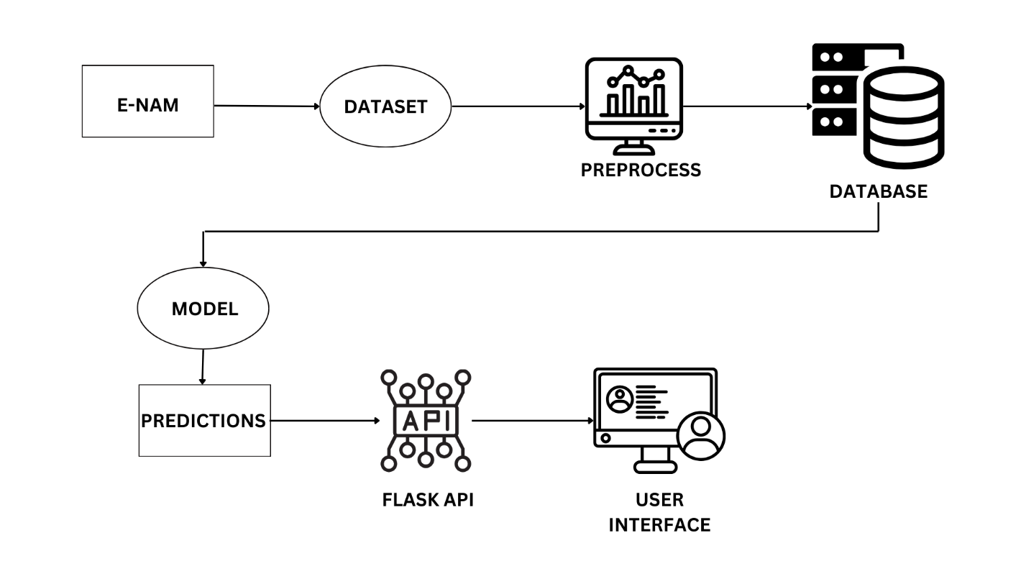Fig 1 system architecture

**4.2 Functional Description of the Modules**

The system is divided into multiple functional modules, each responsible for a specific aspect of agricultural price prediction. These modules work together to provide a seamless and accurate forecasting experience.

**4.2.1 Data Collection and Preprocessing Module**

This module is responsible for gathering, cleaning, and organizing data for ML model training and real-time predictions.

**Key Functions:**

* Collecting historical and real-time agricultural market data from government sources, APIs, and databases.
* Storing data in MongoDB, ensuring efficient retrieval and reference for AI models.
* Encoding categorical values (e.g., state, district, market, commodity) to make them suitable for ML processing.
* Performing data preprocessing (handling missing values, normalizing data, and feature engineering).

**Technologies Used:**

* Python, Pandas, NumPy, MongoDB

**4.2.2 AI/ML Model Processing Module**

This module is responsible for training, optimizing, and deploying AI/ML models for price prediction.

**Key Functions:**

* Training various ML models such as LSTM, Random Forest, XGBoost, and Linear Regression on historical agricultural data.
* Evaluating model performance using metrics such as Mean Squared Error (MSE) and R² scores.
* Deploying the best-performing model (LSTM) as a REST API for real-time price forecasting.
* Continuously updating and retraining models to improve accuracy based on new data.

**Technologies Used:**

* TensorFlow/Keras, Scikit-learn, FastAPI, Flask.

**4.2.3 User Interface and API Integration Module**

This module focuses on user interaction, data visualization, and integration of API services.

**Key Functions:**

* Providing a web-based platform (React.js) where farmers and traders can access real-time price predictions, historical trends, and market insights.
* Implementing a user-friendly dashboard with charts, tables, and filtering options.
* Integrating REST APIs to fetch ML-generated predictions and display them dynamically.
* Allowing farmers to input their commodities, receive market insights, and make informed decisions.

**Technologies Used:**

* React.js, JavaScript, Node.js, REST APIs**.**

**Chapter 5**

**Implementation of the AI Powered Crop Price Recommendation System**

This chapter discusses the implementation details of the Agricultural Price Prediction System, including the selection of programming languages and platforms that best support the system’s requirements. The choices made are based on factors such as performance, scalability, compatibility, and ease of development.

**5.1 Programming Language Selection**

The selection of programming languages for this project is based on the functional requirements of different system components, such as data processing, machine learning model development, backend API services, and frontend user interface.

**5.1.1. Python (For AI/ML Development and Backend API Services)**

* **Reason for Selection**: Python is the industry standard for AI/ML development due to its extensive libraries, ease of implementation, and strong community support.
* **Use Cases in the Project**:
  + Implementing Machine Learning models (LSTM, Random Forest, XGBoost).
  + Data preprocessing and cleaning using Pandas and NumPy.
  + Developing the Flask/FastAPI backend to serve AI models as REST APIs.
  + Handling database operations with MongoDB.

**5.1.2. Backend – Java (Spring Boot)**

* The backend is built using Spring Boot, a Java-based framework that simplifies web service development.
* Spring Boot was chosen for its robustness, scalability, and built-in support for REST APIs, making it ideal for handling large volumes of agricultural data.
* Features like dependency injection, security, and database integration (PostgreSQL and MongoDB) make Spring Boot a powerful choice for this project.

**5.1.3. Frontend – JavaScript (React.js)**

* The frontend is developed using React.js, a popular JavaScript library for building dynamic and interactive web applications.
* React.js provides a responsive user interface, allowing farmers and traders to access real-time price predictions efficiently.
* The framework enables component-based development, reducing redundancy and improving maintainability.

**5.1.4. SQL & NoSQL (For Database Management)**

* MongoDB (NoSQL): Used for storing encoded agricultural data, providing scalability and flexibility for managing real-time market data.
* PostgreSQL (SQL): Used for handling structured transactional data, such as user accounts, order history, and payments.

**5.2 Platform Selection**

Since the project is still in the development phase, the following platforms are being used for coding, testing, and validation before deployment:

* + 1. **Backend Development – Spring Boot (Java)**

The backend is developed and tested in a local development environment using:

* Spring Boot framework for API development.
* Postman for API testing and validation.
* Spring JPA for database connectivity.

**5.2.2. Frontend Development – React.js**

The frontend is developed using:

* React.js and JavaScript for UI development.
* Localhost testing via Node.js and npm package manager.

**5.2.3. AI Model Development – Python (Jupyter Notebook/Colab)**

The AI/ML models are trained and tested using:

* Jupyter Notebook / Google Colab for model training and performance evaluation.
* Matplotlib & Seaborn for visualizing prediction trends.
* Local JSON-based storage for testing model outputs.

**5.2.4. Database Management – MongoDB & PostgreSQL (Local Testing)**

* MongoDB (Local Instance) is used to store encoded values for real-time AI model reference.
* PostgreSQL (Local Instance) is used for storing structured agricultural trade data.

**Chapter 6**

**Experimental Results and Analysis of the AI Powered Crop Price Recommendation System**

This chapter presents the experimental results and performance evaluation of the Agricultural Price Prediction System. The evaluation is based on various machine learning models trained on real-world agricultural datasets. We analyze the system’s effectiveness by assessing prediction accuracy, model efficiency, and error rates using well-established evaluation metrics.

**6.1 Evaluation Metrics**

To measure the accuracy and reliability of the implemented machine learning models, we use the following evaluation metrics:

* **Mean Squared Error (MSE)**
* MSE calculates the average squared difference between actual and predicted prices.
* A lower MSE value indicates higher model accuracy and fewer large errors.
* **Root Mean Squared Error (RMSE)**
* RMSE represents the standard deviation of prediction errors.
* It helps interpret the error magnitude in the same units as the predicted prices.
* **Mean Absolute Error (MAE)**
* MAE measures the average absolute difference between predicted and actual values.
* Unlike MSE, it does not penalize large errors as much, making it less sensitive to extreme outliers.
* **R² Score (Coefficient of Determination)**
* The R² score measures how well the predicted values match actual values.
* A score closer to 1 indicates a strong correlation, while a value closer to 0 suggests weak predictive power.

These metrics are used to compare different models such as LSTM, Random Forest, XGBoost, Linear Regression, and Neural Networks to determine the best-performing algorithm for real-time price prediction.

**6.2 Experimental Dataset**

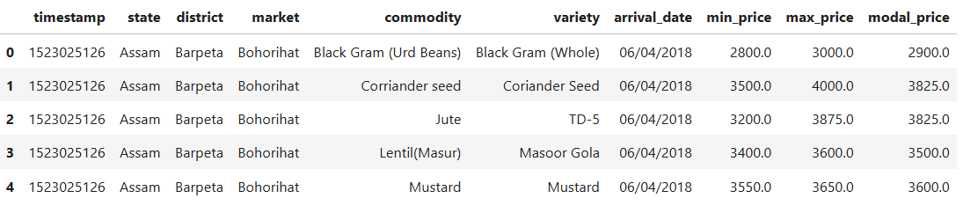**6.2.1. Dataset Structure**

Fig 2 dataset

The dataset includes the following attributes

* State, District, and Market ID: Encoded identifiers for location reference.
* Commodity Name & Category: The type of agricultural product (e.g., wheat, rice, pulses).
* Price Information: Historical minimum, maximum, and modal prices.
* Market Trends: Supply-demand fluctuations, seasonal variations.

**6.2.2. Preprocessing Steps**

* Handling Missing Data: Replacing null values using interpolation techniques.
* Feature Encoding: Converting categorical values (e.g., states, markets) into numerical formats.
* Scaling: Normalizing price data for better model training.
* 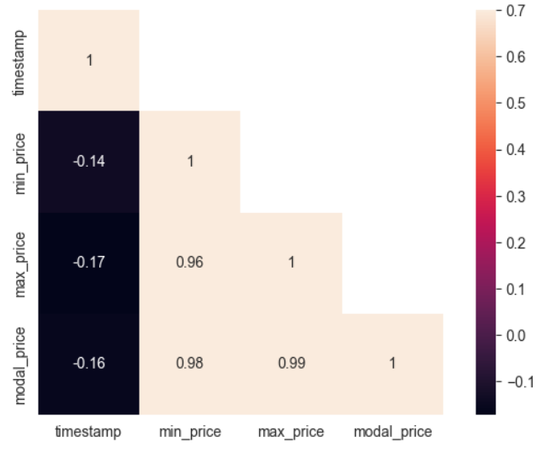Finding correlation between numerical attributes.

Fig 3 correlation between numerical attributes

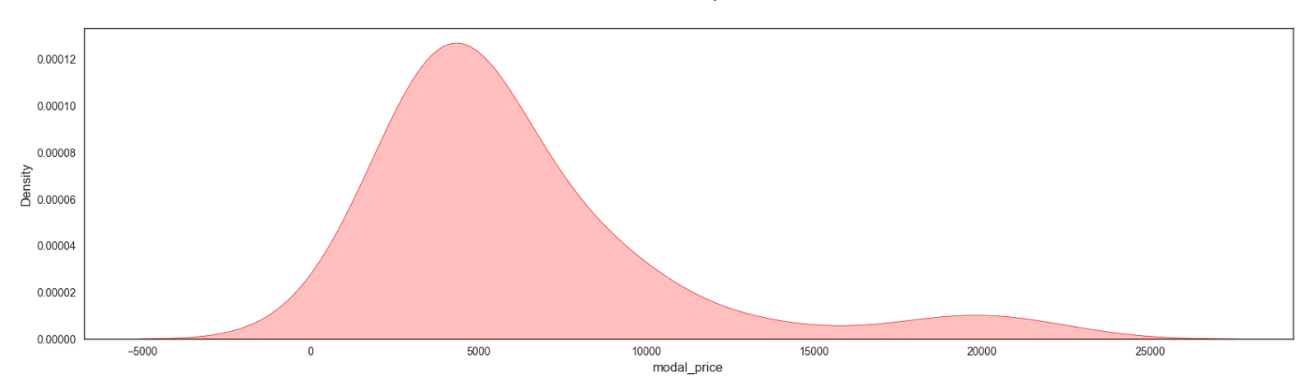**6.2.3. Visualization of dataset**

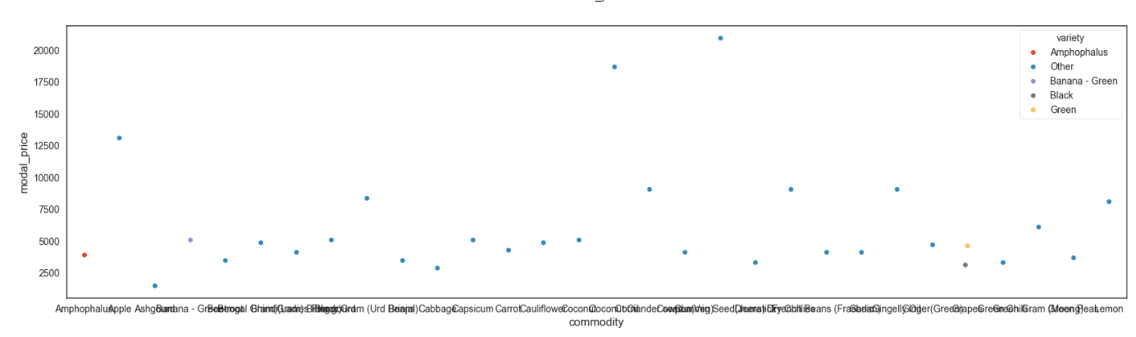Fig 4 Data distribution of Target attribute

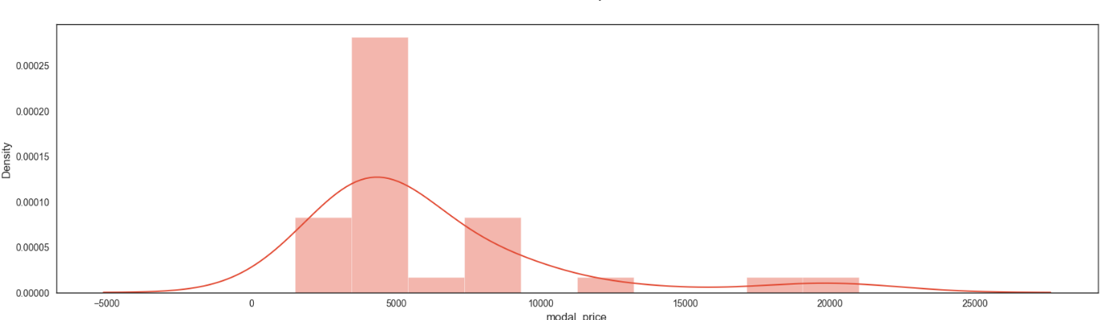Fig 5 Scatter plot for Outlier detection

Fig 6 Target variable analysis

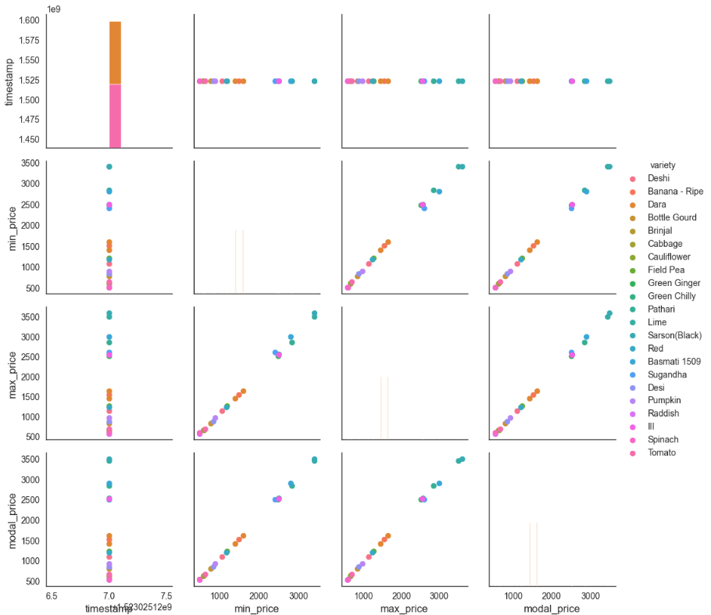Fig 7 Pair plot for relationship between attributes

**6.3 Performance Analysis**

To determine the best-performing model, multiple machine learning techniques were applied to the dataset, and their results were compared.

**6.3.1. Model Comparisons**

Table 1 Performance Comparison

|  |  |  |
| --- | --- | --- |
| **Model** | **MSE (Mean Squared Error)** | **R² Score** |
| **LSTM** | 0.0002 | 1.7745 |
| **Random Forest** | 0.0001 | 0.4185 |
| **XGBoost** | 0.0000 | 0.7164 |
| **Linear Regression** | 0.0003 | 1.9104 |
| **Neural Network** | 64.8853 | 731495.3613 |
| **Polynomial Regression** | 0.0016 | 16.5184 |

**6.3.2. Observations and Analysis**

* XGBoost achieved the lowest MSE (0.0000), indicating the highest accuracy among all models. This suggests that XGBoost effectively captures market trends and price variations.
* LSTM performed well (MSE: 0.0002, R²: 1.7745), showing strong time-series forecasting capabilities. Its ability to process sequential dependencies makes it a suitable model for price prediction over time.
* Random Forest produced moderate results (MSE: 0.0001, R²: 0.4185). While it captures feature importance well, it might not be as effective in time-series predictions compared to LSTM.
* Linear Regression had a slightly higher error (MSE: 0.0003), but its R² score (1.9104) suggests it could explain price trends to some extent. However, the model struggles with non-linear relationships in commodity pricing.
* Polynomial Regression showed high MSE (0.0016) and an R² score of 16.5184, suggesting it overfits the data.
* The Neural Network model performed unexpectedly poorly (MSE: 64.8853, R²: 731495.3613), likely due to overfitting, incorrect hyperparameters, or data scaling issues.

**6.3.3. Best Model Selection**

* XGBoost is the most effective model for price prediction due to its lowest MSE (0.0000) and a strong R² score (0.7164).
* LSTM remains a viable option, particularly for long-term forecasting where sequential dependencies are critical.
* Random Forest and Linear Regression show moderate performance, but they might require further tuning to improve accuracy.
* Neural Networks need hyperparameter adjustments, as the current results indicate potential overfitting or improper learning.

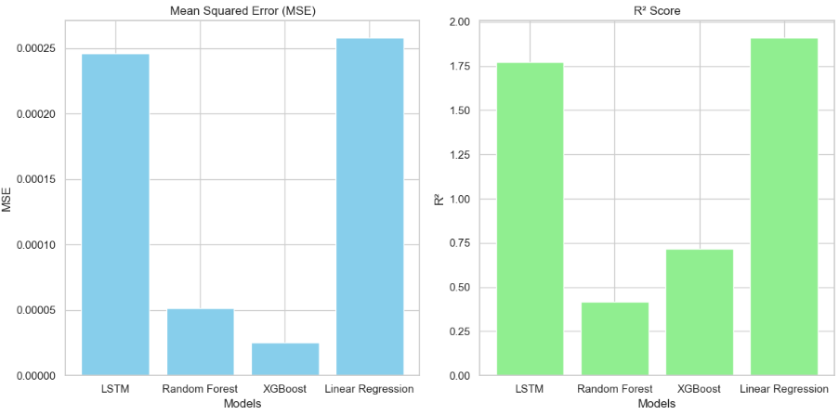Fig 8 Comparison between Models

This section provided a detailed evaluation of AI/ML models used for price prediction. XGBoost outperformed all other models, making it the optimal choice for real-time agricultural price forecasting. The LSTM model remains a strong alternative for long-term predictions. These findings validate the importance of AI-driven decision-making in optimizing agricultural trade and highlight areas for further improvements.

**Chapter 7**

**Conclusion and Future Enhancement**

This chapter presents the final conclusions of the Agricultural Price Prediction System, and outlines potential future enhancements to improve its accuracy, scalability, and usability.

**7.1 Summary**

This project successfully developed a data-driven agricultural price prediction system, integrating AI and ML models to assist farmers, traders, and consumers in making informed pricing decisions. The XGBoost model performed best, demonstrating high accuracy, while LSTM remained a strong candidate for time-series forecasting.

However, certain limitations, such as lack of real-time data integration and model retraining challenges, need to be addressed. Future enhancements include deploying the system, improving model accuracy, adding real-time data streams, and expanding user features to enhance usability.

The Agricultural Price Prediction System has the potential to revolutionize agriculture-based trading, ensuring better market transparency, increased profits for farmers, and improved decision-making for stakeholders. With further improvements, the system can become a valuable tool in the digital transformation of the agricultural sector.

**7.2 Future Enhancements**

To improve the system and make it more scalable, efficient, and user-friendly, several enhancements are planned. Model optimization and feature expansion will involve further fine-tuning of hyperparameters in Neural Networks and Polynomial Regression to enhance accuracy. Additionally, the system will incorporate hybrid models that combine time-series analysis (LSTM) with ensemble techniques (XGBoost, Random Forest) to improve prediction reliability and performance.

Another key enhancement is the introduction of AI-powered market insights, which will help farmers make better-informed decisions. This includes implementing demand forecasting models that assist farmers in planning crop production based on projected market trends. Furthermore, the system will feature automated alerts and notifications that notify farmers about significant price fluctuations, ensuring they can take timely actions to maximize profits and reduce risks.

To enhance accessibility, a mobile application will be developed, allowing farmers to easily access price predictions, track market trends, and receive personalized recommendations directly from their smartphones. The app will also support multilingual features, ensuring that farmers from different regions can navigate and use the platform effortlessly, regardless of their language preferences. These improvements will make the system more adaptable and beneficial to a wider range of users in the agricultural sector.

**REFERNCE**

1. *Elavarasan, Dhivya, and PM Durairaj Vincent. "Crop yield prediction using deep reinforcement learning model for sustainable agrarian applications." IEEE access 8 (2020): 86886-86901.*
2. *Huang, Jianxi, et al. "Assimilation of remote sensing into crop growth models: Current status and perspectives." Agricultural and Forest Meteorology 276 (2019): 107609.*
3. *Holzman, Mauro E., et al. "Early assessment of crop yield from remotely sensed water stress and solar radiation data." ISPRS journal of photogrammetry and remote sensing 145 (2018): 297-308.*
4. *Singh, Arti, et al. "Machine learning for high-throughput stress phenotyping in plants." Trends in plant science 21.2 (2016): 110-124.*
5. *Whetton, R., Zhao, Y., Shaddad, S., & Mouazen, A. M. (2017). Nonlinear parametric modelling to study how soil properties affect crop yields and NDVI. Computers and electronics in agriculture, 138, 127-136.*
6. *Dash, Y., Mishra, S. K., & Panigrahi, B. K. (2018). Rainfall prediction for the Kerala state of India using artificial intelligence approaches. Computers & Electrical Engineering, 70, 66-73.*
7. *Wieder, W., Shoop, S., Barna, L., Franz, T., & Finkenbiner, C. (2018). Comparison of soil strength measurements of agricultural soils in Nebraska. Journal of Terramechanics, 77, 31-48.*
8. *Chlingaryan, A., Sukkarieh, S., & Whelan, B. (2018). Machine learning approaches for crop yield prediction and nitrogen status estimation in precision agriculture: A review. Computers and electronics in agriculture, 151, 61-69.*
9. *Basso, B., & Liu, L. (2019). Seasonal crop yield forecast: Methods, applications, and accuracies. advances in agronomy, 154, 201-255.*
10. *Shahhosseini, M., Martinez-Feria, R. A., Hu, G., & Archontoulis, S. V. (2019). Maize yield and nitrate loss prediction with machine learning algorithms. Environmental Research Letters, 14(12), 124026.*
11. *F. Sun, X. Meng, Y. Zhang, Y. Wang, H. Jiang, and P. Liu, “Agricultural product price forecasting methods: A review,”* Agriculture*, vol. 13, no. 9, pp. 1671, Sep. 2023.*
12. *D. Sandhu, P. N. Kulkarni, S. A. M, R. Mishra, P. Khetan, and A. Bhadora, “Agricultural price prediction through artificial intelligence,”* Int. J. Dev. Res.*, vol. 14, no. 3, pp. 65161–65165, Mar. 2024.*
13. *R. Saxena, R. K. Paul, S. Pavithra, N. P. Singh, and R. Kumar, “Methods and effectiveness of agricultural commodity price forecasts,”* J. Commodity Markets*, vol. 10, no. 1, pp. 78–92, 2023.*
14. *E. Elbasi, C. Zaki, A. E. Topcu, W. Abdelbaki, A. I. Zreikat, E. Cina, A. Shdefat, and L. Saker, “Crop prediction model using machine learning algorithms,”* Appl. Sci.*, vol. 13, no. 16, pp. 9288, 2023.*
15. *T. Zhang and Z. Tang, “Agricultural commodity futures prices prediction based on a new VMD-SGMD-LSTM model,”* J. Futures Markets*, vol. 35, no. 6, pp. 456–470, 2023.*
16. *G. M. Mohyuddi, M. A. Khan, A. Haseeb, S. Mahpara, M. Waseem, and A. M. Saleh, “A comparative study of machine learning techniques for agricultural price forecasting,”* IEEE Xplore*, vol. 11, no. 2, pp. 150–162, 2024.*

**Appendices**

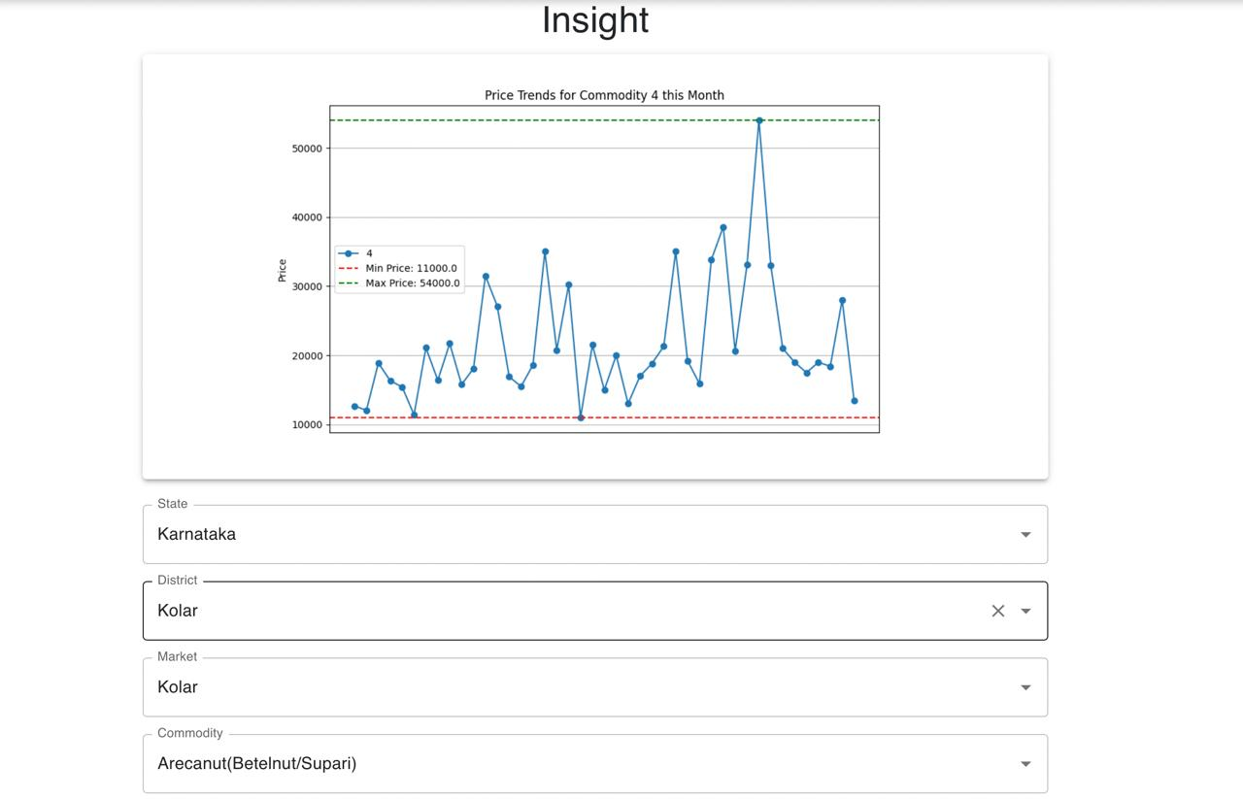**Appendix 1: Screenshots**

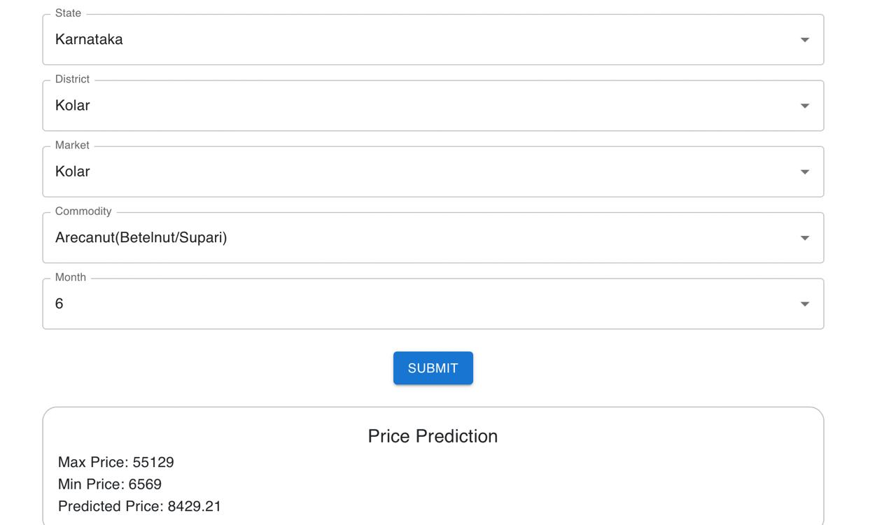Fig 9 Price Trends for Commodity

Fig 10 Price Prediction

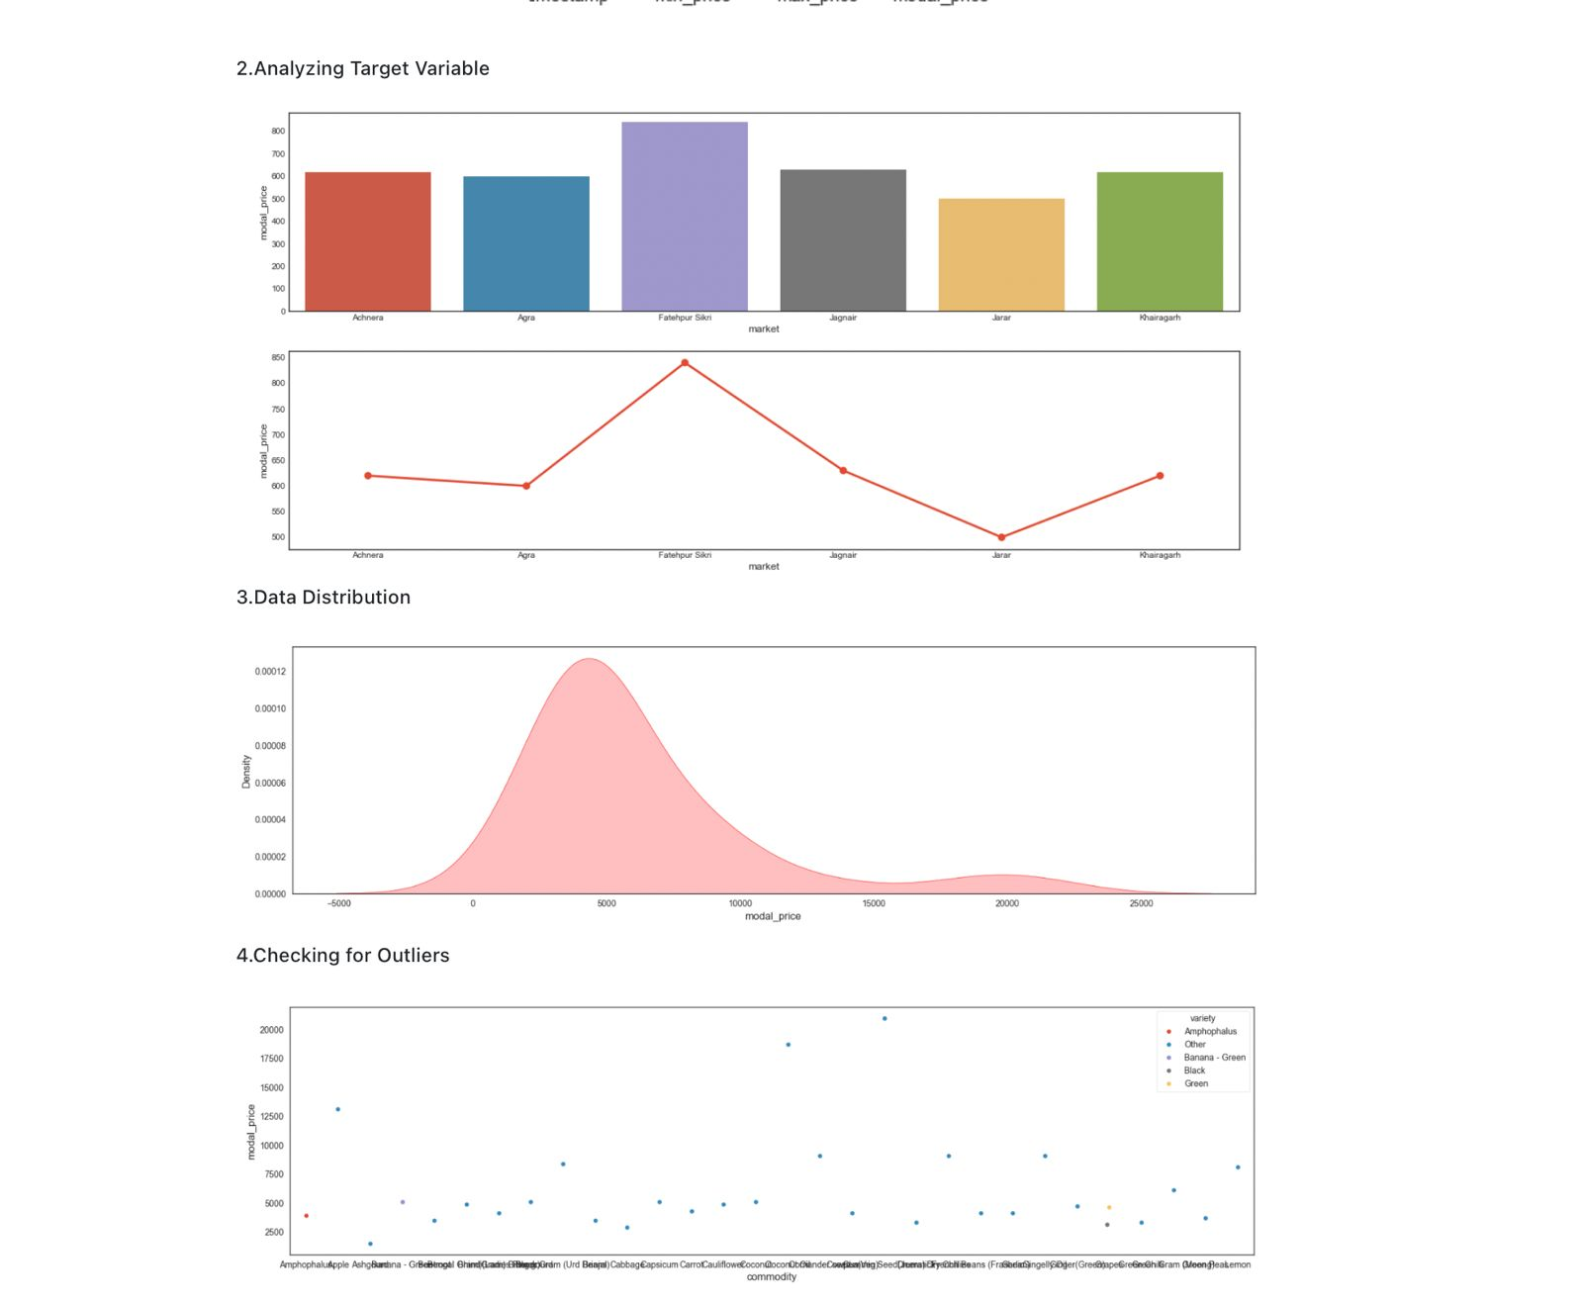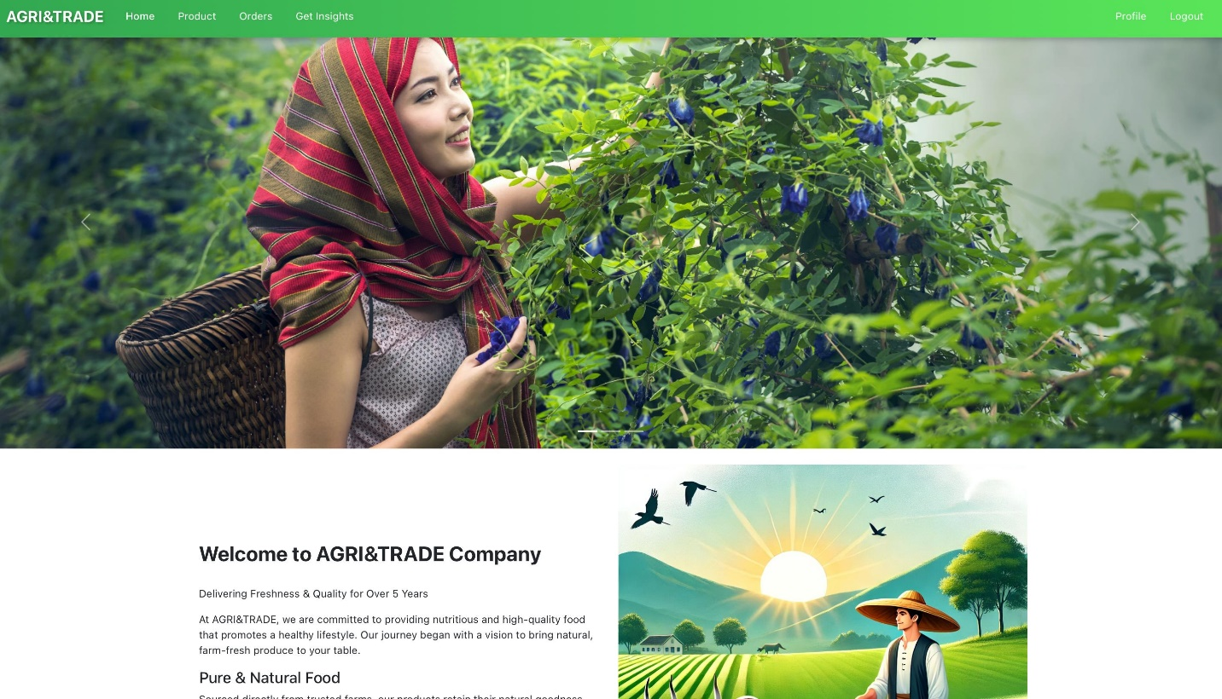Fig 11 User Interface

Fig 12 Analytics